Touch-point three: involving people

Co production

Principles for Structuring co design

- Involve everyone who will be taking part in the co-production from the start.
- Value and reward people who take part in the co-production process.
- Ensure that there are resources to cover the cost of co-production activities.
- Ensure that co-production is supported by a strategy that describes how things are going to be communicated.
- Build on existing structures and resources

From SCIE co production guide 51 - http://www.scie.org.uk/publications/guides/guide51/

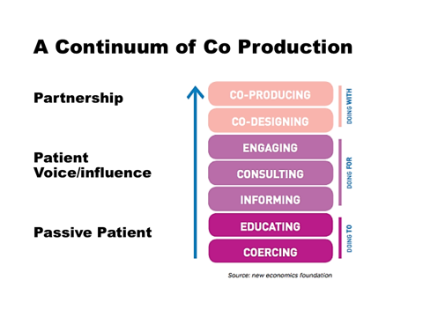

Some useful, but challenging questions for discussion about the role of service users in organisations and collaborative relationships between service users and care professionals

- What makes collaboration between care professionals, patients and communities work well in your experience?
- What are the roles for Patients, service users and carers as partners in your work?
- What defines the relationship between service users and care professionals in your context?
- How does your organisational culture impact on the relationship?
- How does power impact on the relationship?
- What needs to change to allow more collaborative relationships between HCP’s, patients and communities in your work?

Environments for constructive dialogue

It is important to think about the environment for the conversation you want to have and to create the right balance between support and challenge. The following table can help you to think about the impact of varying degrees of support and challenge in your conversations.

