Touch-point seven: system leadership practices

1. In the Dawn of system Leadership Peter Senge, draws a distinction between the characteristics of personal, organisational system leadership. (http://ssir.org/articles/entry/the_dawn_of_system_leadership )

2. A practical case study of how a whole system leadership approach supported local change. http://www.kingsfund.org.uk/publications/system-leadership
3. “The revolution will be improvised”, is a report on the work of the National System Leadership Programme in England. It offers the following definition –
“Systems Leadership is a way of working that shares the burden
of leadership to achieve large-scale change across communities.
It goes beyond organisational boundaries and extends across staff at all levels, professions and sectors. It involves people using services, and carers, in the design and delivery of those services. Systems Leadership recognizes that leadership is not vested in people solely through their authority or position; so it involves sharing leadership with others, coming together on the basis of a shared ambition and working together towards solutions.”
For more information see - http://www.localleadership.gov.uk/docs/Revolution%20will%20be%20improvised%20publication%20v3.pdf
- System leadership – a view from the bridge by Sue Goss (OPM) offers an overview of system leadership and a helpful 6-point reference for system leadership practices. http://tinyurl.com/p9c4rv2

- NHS Education for Scotland

http://www.nes.scot.nhs.uk/newsroom/features-and-articles/leadership-for-integration-launch.aspx

Ralph Stacey, Professor of Management at Hertfordshire Business School, University of Hertfordshire has developed the following model to help leaders distinguish between how to behave in different contexts, depending on the nature of the problems they ae facing. The orange circle describes behaviours and practices that can support system leadership.

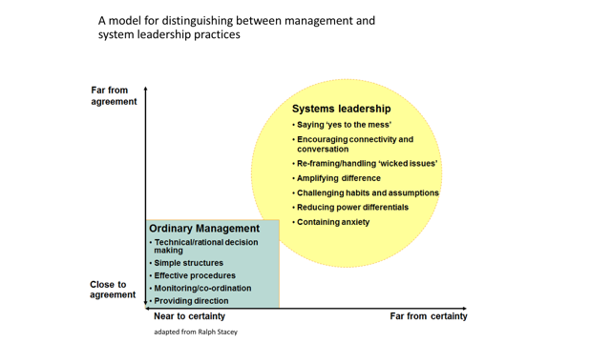
A view from the Bridge by Sue Goss at OPM (http://tinyurl.com/p9c4rv2 ) describes 6 dimensions od system leadership.
“From the literature, from international case studies and from real examples of systems change, we can identify six dimensions of systems leadership:
1. Ways of feeling – about strong personal values;
2. Ways of perceiving – about listening observing and understanding;
3. Ways of thinking – about intellectual rigour in analysis and synthesis;
4. Ways of relating – the conditions that enable and support others;
5. Ways of doing – behaving in ways that lead to change; and
6. Ways of being – personal qualities that support distributed leadership.

