Touch-point five: horizon scanning tool: workforce planning for an integrated world

What is Horizon Scanning?

According to the OECD,

“Horizon scanning is a technique for detecting early signs of potentially important developments through a systematic examination of potential threats and opportunities, with emphasis on new technology and its effects on the issue at hand. The method calls for determining what is constant, what changes, and what constantly changes. It explores novel and unexpected issues as well as persistent problems and trends, including matters at the margins of current thinking that challenge past assumptions.
Horizon scanning is often based on desk research, helping to develop the big picture behind the issues to be examined. Desk research involves a wide variety of sources, such as the Internet, government ministries and agencies, non-governmental organisations, international organisations and companies, research communities, and on-line and off-line databases and journals. Horizon scanning can also be undertaken by small groups of experts who are at the forefront in the area of concern: They share their perspectives and knowledge with each other so as to 'scan' how new phenomena might influence the future.
A solid 'scan of the horizon' can provide the background to develop strategies for anticipating future developments and thereby gain lead time. It can also be a way to assess trends to feed into a scenario development process”.
https://www.oecd.org/site/schoolingfortomorrowknowledgebase/futuresthinking/overviewofmethodologies.htm)

Benefits of Horizon Scanning in supporting workforce planning

- Reviews a broad spectrum of information, beyond usual timescales and sources.
- Draws insights from users of services and the workforce themselves
- Identifies future challenges and trends.
- Signposts future risk factors
- Supports innovation in service provision
- Support best practice in service improvement

Scan data sources

Scanning data may be collected and organised through

- Personal scanning – focusing on the views of those receiving services

- Task specific scanning – focusing on a specific theme or service, Self Directed Support or diabetes services

- Organisational scanning - focusing on the views of those delivering services and the wider workforce

- Sector scanning – data from the wider health and social care sector and policy direction from national and international bodies

Basic four-point starter guide to setting up a scan around workforce planning

- Gather information: The ‘scanning team’ is brought together from across the partnership. The team begins to gather information from a wide range of sources about the current and future trends which might impact on delivery of health and social care within their partnership. This information should be drawn from a wide variety of sources, but should include as much qualitative data from users of services as possible, and should not be too tightly focused.

- Spot signals: The scanning team will begin to see patterns and signal in the information gathered. This may suggest an emerging trend, of interest to the organisation; sometime called ‘cues and clues’. Each issue can be numbered and listed in a workbook. The data could be separated out to reflect locality areas.

- Watch trends: The scanning team begin to track some of the emerging trends to get a clearer, wider picture of the pace and direction they are taking. The template below may be useful at this point.

- Agree the response: Analysts, strategic leads and commissioners start to look at the scan and try make sense of the trends and the likely impact on the business and workforce.

Template

Some scans are developed using a traffic light system where the colour signifies the strength of the signal in relation to having an impact on the delivery of service of the workforce themselves. However, a simple template can be used to watch for trends, and is a simple visual way of explaining scan data to decision-makers, can be seen below:-

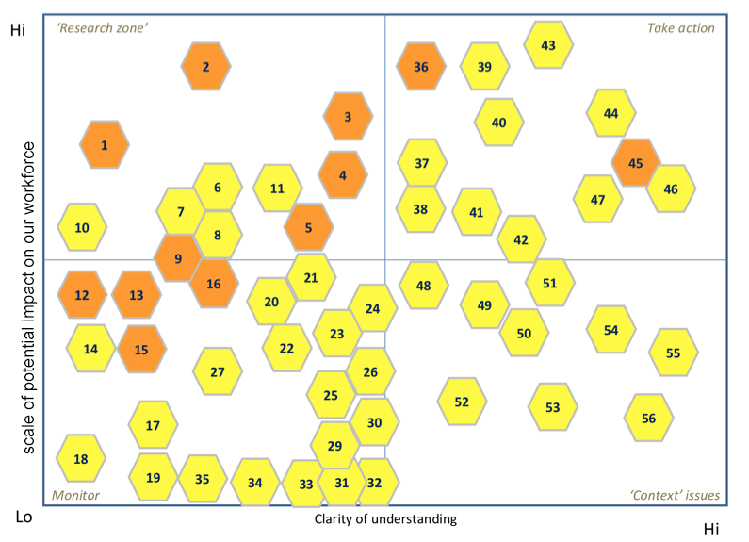

Key

Research - The organisation may need to understand the issue in more depth and might commission further research into the likely effects.

Context issue – Recognition this is a background issue and something that provides ‘mood music’ rather than a specific impact. For example, an upcoming political election or a financial or regulatory review period.

Monitoring – These are issues that emerge from the scan where early patterns may be discernable. These are issues that are important to revisit, monitor closely and access on an on-going basis.

Action – These are issues where there is clear and strong patterns evident, from a number of sources, and which will likely impact on the nature of service delivery and the roles/ composition of the workforce in the short, medium or long term.

